General Page Template Design

Header - My website will have multiple pages to be navigated to from horizontal header links available on all pages. Links will be named appropriately for ease of understanding and navigation. Website Logo will be aligned to the left.

Body – Main content of the site will be centered and one column.

Footer – Will contain copyright as well as contact information.

All pages will be a similar style offering predictability for the users to be comfortable using.

Color Palette

The target audience of this website will be for bird dog owners (German shorthaired pointers). A large demographic of these dog owners are hunters, therefore the best color palette for the website should be earth tones. I’m not sold on definite colors yet until I see how they look on the project, but the background will need to be a beige similar to #E1CAB2 for legibility purposes and text will be black

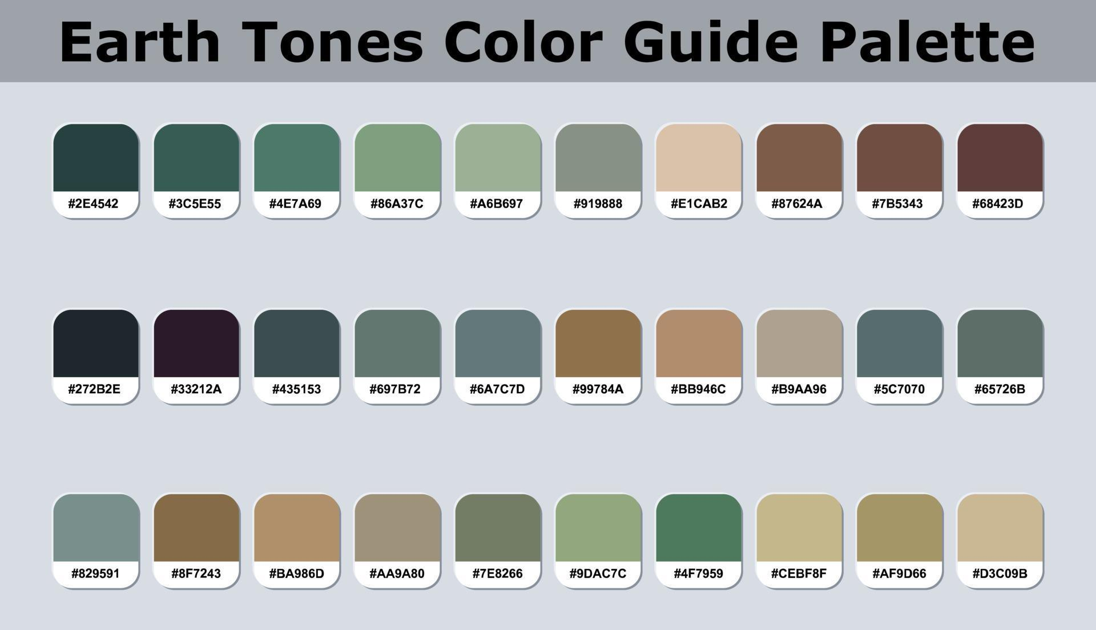  
Typography Choices

Due to the simplicity of this website, I’ll stick to easy-to-read sharp font choices. The headlines will be centered using Lato font. Lato is easy to read with a more artistic flare. The content text will be set to the left using Lora font. Lora font is simplistic in nature and easy to read. Lines will be limited to 100 characters or less.